## Objective: Formatting web pages with CSS [Create semester project website’s inner pages

# Code :-

# Home Page:-

# HTML :-

# <!DOCTYPE html>

# <html lang="en">

# <head>

# <meta charset="UTF-8">

# <meta name="viewport" content="width=device-width, initial-scale=1.0">

# <title>Competitive Programming Club</title>

# <link rel="stylesheet" href="./styles.css">

# </head>

# <body>

# <header>

# <nav>

# <div class="container">

# <h1>Competitive Programming Club</h1>

# <ul>

# <li><a href="#">Home</a></li>

# <li><a href="#">About Us</a></li>

# <li><a href="#">Events</a></li>

# <li><a href="#">Resources</a></li>

# <li><a href="#">Contact</a></li>

# </ul>

# </div>

# </nav>

# </header>

# <div class="slider">

# <img src="./1.png" alt="Image 1">

# <img src="./2.png" alt="Image 2">

# <img src="./3.png" alt="Image 3">

# <img src="./4.png" alt="Image 4">

# <img src="./11.png" alt="Image 5">

# <img src="./12.png" alt="Image 6">

# </div>

# <script>

# let currentSlide = 0;

# const slides = document.querySelectorAll('.slider img');

# const totalSlides = slides.length;

# function showSlide(index) {

# slides.forEach((slide) => {

# slide.style.display = 'none';

# });

# slides[index].style.display = 'block';

# }

# function nextSlide() {

# currentSlide = (currentSlide + 1) % totalSlides;

# showSlide(currentSlide);

# }

# function prevSlide() {

# currentSlide = (currentSlide - 1 + totalSlides) % totalSlides;

# showSlide(currentSlide);

# }

# 

# showSlide(currentSlide);

# 

# setInterval(nextSlide, 5000);

# </script>

# </body>

# </html>

# CSS:-

# * {

# margin: 0;

# padding: 0;

# box-sizing: border-box;

# }

# body {

# font-family: Arial, sans-serif;

# }

# .container {

# max-width: 1200px;

# margin: 0 auto;

# padding: 0 20px;

# }

# header {

# background-color: #333;

# color: #fff;

# padding: 20px 0;

# }

# nav ul {

# list-style-type: none;

# }

# nav ul li {

# display: inline;

# margin-right: 20px;

# }

# nav ul li a {

# text-decoration: none;

# color: #fff;

# }

# .slider {

# width: 100%;

# max-width: 1000px;

# margin: 20px auto;

# overflow: hidden;

# }

# .slider img {

# width: 100%;

# display: none;

# }

# @keyframes slide {

# 0% {

# opacity: 0;

# }

# 25% {

# opacity: 1;

# }

# 75% {

# opacity: 1;

# }

# 100% {

# opacity: 0;

# }

# }

# .slider img {

# animation: slide 12s infinite;

# }

**Output :-**

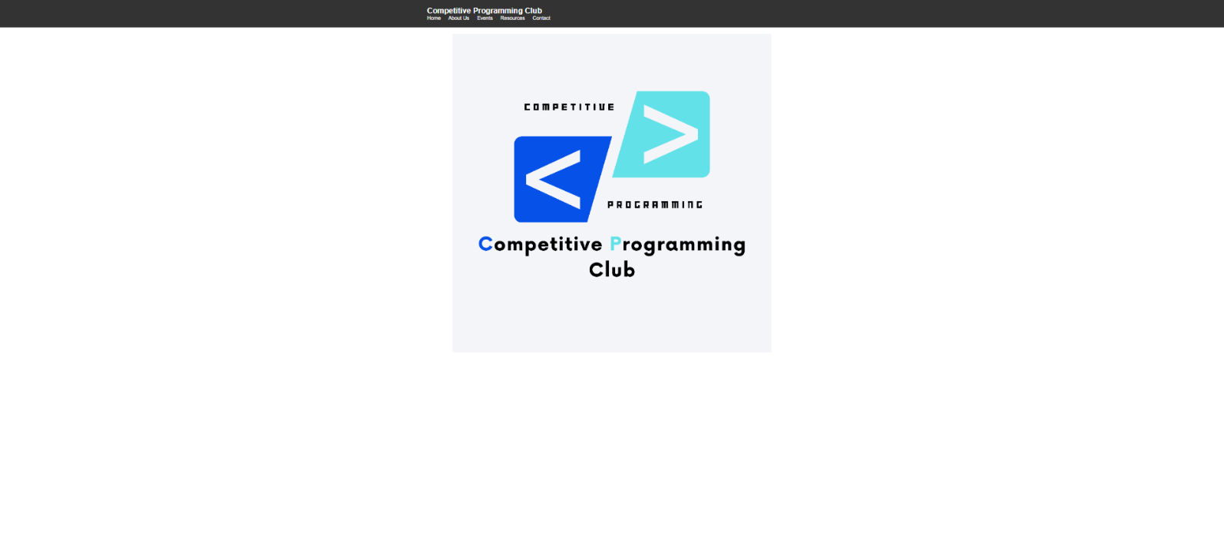

# Registration Form:-

# HTML :-

# <!DOCTYPE html>

# <html lang="en">

# <head>

# <meta charset="UTF-8">

# <meta http-equiv="X-UA-Compatible" content="IE=edge">

# <meta name="viewport" content="width=device-width, initial-scale=1.0">

# <title>Responsive Registration Form</title>

# <link rel="stylesheet" href="./Form.css">

# </head>

# <body>

# <div class="container">

# <header>Registration</header>

# <form action="#">

# <div class="form first">

# <div class="details personal">

# <span class="title">Personal Details</span>

# <div class="fields">

# <div class="input-field">

# <label>Full Name</label>

# <input type="text" placeholder="Enter your name" required>

# </div>

# <div class="input-field">

# <label>Institute Email</label>

# <input type="email" placeholder="Enter your institute email" required>

# </div>

# <div class="input-field">

# <label>Personal Mail</label>

# <input type="email" placeholder="Enter your personal email" required>

# </div>

# <div class="input-field">

# <label>Phone Number</label>

# <input type="tel" placeholder="Enter your phone number" required>

# </div>

# <div class="input-field">

# <label>Department</label>

# <select required>

# <option disabled selected>Select department</option>

# <option value="CE-AI">CE-AI</option>

# <option value="ICT">ICT</option>

# <option value="CE">CE</option>

# <option value="BIO INFORMATICS">BIO INFORMATICS</option>

# <option value="IT">IT</option>

# <option value="BCA">BCA</option>

# <option value="MCA">MCA</option>

# </select>

# </div>

# <div class="input-field">

# <label>Batch Year</label>

# <input type="number" placeholder="Enter your batch year" required>

# </div>

# <div class="input-field">

# <label>Enrollment No</label>

# <input type="text" placeholder="Enter your enrollment number" required>

# </div>

# </div>

# </div>

# </div>

# <div class="buttons">

# <button class="register">

# <span class="btnText">Register</span>

# <i class="uil uil-navigator"></i>

# </button>

# <button class="alreadyRegistered">

# <span class="btnText">Already Registered</span>

# <i class="uil uil-navigator"></i>

# </button>

# </div>

# </form>

# </div>

# <script src="./Form.js"></script>

# </body>

# </html>

# CSS :-

# @import url('https://fonts.googleapis.com/css2?family=Poppins:wght@200;300;400;500;600&display=swap');

# * {

# margin: 0;

# padding: 0;

# box-sizing: border-box;

# font-family: 'Poppins', sans-serif;

# }

# body {

# min-height: 100vh;

# display: flex;

# align-items: center;

# justify-content: center;

# background: #4070f4;

# }

# .container {

# position: relative;

# max-width: 900px;

# width: 100%;

# border-radius: 6px;

# padding: 30px;

# margin: 0 15px;

# background-color: #fff;

# box-shadow: 0 5px 10px rgba(0, 0, 0, 0.1);

# }

# .container header {

# position: relative;

# font-size: 20px;

# font-weight: 600;

# color: #333;

# }

# .container header::before {

# content: "";

# position: absolute;

# left: 0;

# bottom: -2px;

# height: 3px;

# width: 27px;

# border-radius: 8px;

# background-color: #4070f4;

# }

# .container form {

# position: relative;

# margin-top: 16px;

# min-height: 490px;

# background-color: #fff;

# overflow: hidden;

# }

# .container form .form {

# position: absolute;

# background-color: #fff;

# transition: 0.3s ease;

# }

# .container form .form.second {

# opacity: 0;

# pointer-events: none;

# transform: translateX(100%);

# }

# form.secActive .form.second {

# opacity: 1;

# pointer-events: auto;

# transform: translateX(0);

# }

# form.secActive .form.first {

# opacity: 0;

# pointer-events: none;

# transform: translateX(-100%);

# }

# .container form .title {

# display: block;

# margin-bottom: 8px;

# font-size: 16px;

# font-weight: 500;

# margin: 6px 0;

# color: #333;

# }

# .container form .fields {

# display: flex;

# align-items: center;

# justify-content: space-between;

# flex-wrap: wrap;

# }

# form .fields .input-field {

# display: flex;

# width: calc(100% / 3 - 15px);

# flex-direction: column;

# margin: 4px 0;

# }

# .input-field label {

# font-size: 12px;

# font-weight: 500;

# color: #2e2e2e;

# }

# .input-field input,

# select {

# outline: none;

# font-size: 14px;

# font-weight: 400;

# color: #333;

# border-radius: 5px;

# border: 1px solid #aaa;

# padding: 0 15px;

# height: 42px;

# margin: 8px 0;

# }

# .input-field input :focus,

# .input-field select:focus {

# box-shadow: 0 3px 6px rgba(0, 0, 0, 0.13);

# }

# .input-field select,

# .input-field input[type="date"] {

# color: #707070;

# }

# .input-field input[type="date"]:valid {

# color: #333;

# }

# .container form button,

# .backBtn {

# display: flex;

# align-items: center;

# justify-content: center;

# height: 45px;

# max-width: 200px;

# width: 100%;

# border: none;

# outline: none;

# color: #fff;

# border-radius: 5px;

# margin: 25px 0;

# background-color: #4070f4;

# transition: all 0.3s linear;

# cursor: pointer;

# }

# .container form .btnText {

# font-size: 14px;

# font-weight: 400;

# }

# form button:hover {

# background-color: #265df2;

# }

# form button i,

# form .backBtn i {

# margin: 0 6px;

# }

# form .backBtn i {

# transform: rotate(180deg);

# }

# form .buttons {

# display: flex;

# align-items: center;

# }

# form .buttons button,

# .backBtn {

# margin-right: 14px;

# }

# @media (max-width: 750px) {

# .container form {

# overflow-y: scroll;

# }

# .container form::-webkit-scrollbar {

# display: none;

# }

# form .fields .input-field {

# width: calc(100% / 2 - 15px);

# }

# }

# @media (max-width: 550px) {

# form .fields .input-field {

# width: 100%;

# }

# }

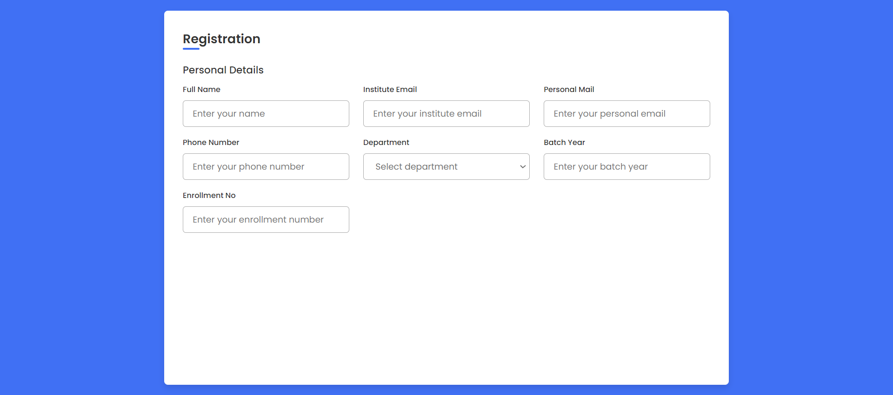**Output :-**

**Log In Page:-**

**HTML :-**

<!DOCTYPE html>

<html lang="en">

<head>

<meta charset="UTF-8">

<meta name="viewport" content="width=device-width, initial-scale=1.0">

<title>Log In - CP Club ICT MU</title>

<link rel="stylesheet" href="https://cdn.jsdelivr.net/npm/bootstrap@5.1.3/dist/css/bootstrap.min.css">

<link rel="stylesheet" href="../css/login.css">

</head>

<body>

<div class="container d-flex justify-content-center align-items-center min-vh-100" id="Container">

<div class="row border rounded-5 p-3 bg-dark shadow box-area">

<div class="col-md-6 rounded-4 d-flex justify-content-center align-items-center flex-column left-box"

style="background-color: aqua;">

<div class="featured-image mb-3">

<img src="../assets/Images/dark.png" class="img-fluid" style="width: 250px;">

</div>

</div>

<div class="col-md-6 right-box">

<div class="row align-items-center">

<div class="header-text mb-4">

<p class="text-white fs-2 text-center"

style="font-family: 'Courier New', Courier, monospace; font-weight: 600;">Log In</p>

</div>

<div class="input-group mb-3">

<input type="text" name="" id="" class="form-control form-control-lg bg-light fs-6"

placeholder="Enter Your Email Address">

</div>

<div class="input-group mb-1">

<input type="password" name="" id="" class="form-control form-control-lg bg-light fs-6"

placeholder="Enter Your Password">

</div>

<div class="input-group mb-5 d-flex justify-content-between">

<div class="form-check">

<input type="checkbox" class="form-ckeck-input" id="formCheck">

<label for="formCheck" class="formCheck-label text-secondary"><small>Remember

Me</small></label>

</div>

<div class="forgot">

<small><a href="#">Forgot Password?</a></small>

</div>

</div>

<div class="input-group mb-3">

<button class="btn btn-lg btn-primary w-100 fs-6">Login</button>

</div>

<div class="row">

<small class="text-white fs-6 text-center"

style="font-family: 'Courier New', Courier, monospace; font-weight: 600;">Don't Have

An Account? <a href="#">Register Here</a></small>

</div>

</div>

</div>

</div>

</div>

</body>

</html>

**CSS Code :-**

@import url('https://fonts.googleapis.com/css2?family=Poppins%3Awght%40400%3B500&display=swap%27%29%3B');

body {

font-family: 'Poppins', 'sans-serif';

}

**Output :-**

